**Lab Tasks**

**Task 1:**

#include<iostream>

using namespace std;

int main(){

float x,y;

char z;

cout<<" first number: ";

cin>>x;

cout<<" second number: ";

cin>>y;

cout<<"enter the operation(*,+,-,/)"<<endl;

cin>>z;

switch(z){

case '*' :

cout<<" Answer= "<< x*y;

break;

case '/':

cout<< " Answer= "<<x/y;

break;

case'+': cout<<" Answer= "<< x+y;

break;

case'-': cout<<"Answer= "<< x-y;

break;

default: cout<< " operation invalid";

}

return 0;

}

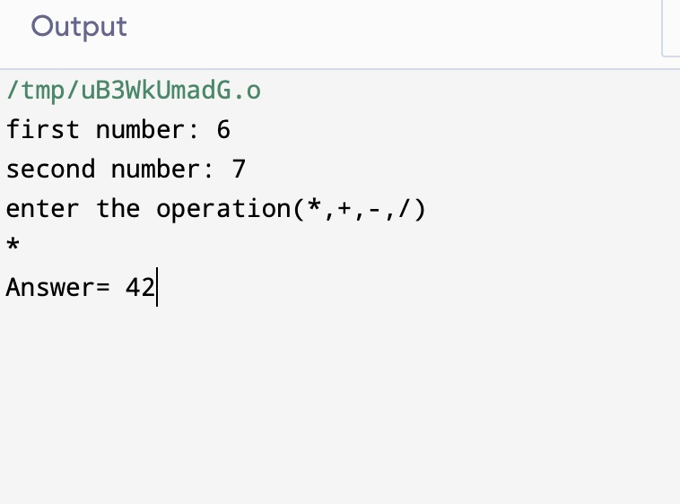

**Task 2:**

#include<iostream>

using namespace std;

int main(){

int a;

cout<<" Enter the month number.";

cin>>a;

switch(a)

{ case 1:;case 3:;case 5:;case 7:;case 8:;case 10:; case 12: cout<<" 31 days";

break;

case 4:; case 6:; case 9:; case 11:

cout<<" 30 days ";

break;

case 2: cout<<" 28 days";

break;

default: cout<<" invalid month number";

}

return 0;

}

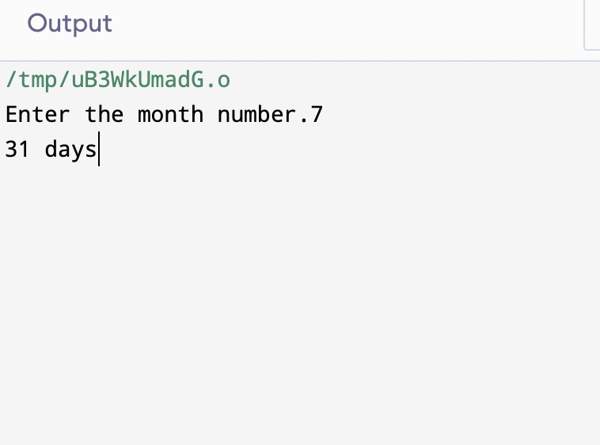

**Task 3:**

#include<iostream>

using namespace std;

int main(){

float l, m;

cout<<" number 1: ";

cin>>l;

cout<<" number 2: ";

cin>>m;

if( l==m)

{cout<<" number 1 is equal to number 2 ";

}

else {

if( l>m)

{cout<<" number 1 is greater than number 2";}

else {

if( m>l)

{ cout<<" number 1 is smaller than number 2";}

}

}

return 0;}

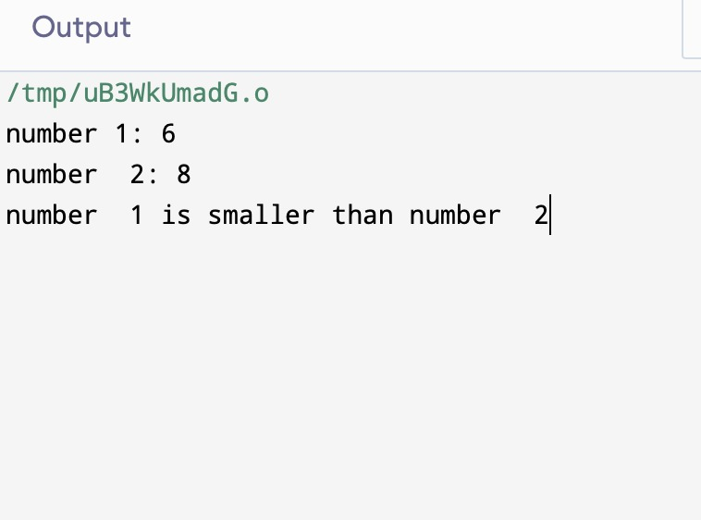

**Task 4:**#include<iostream>

using namespace std;

int main(){

int z,x=1,y=-1;

cout<<" value of z: ";

cin>>z;

if(z>0){

cout<<" n= "<<x;

}

else{

if(z==0){

cout<<" n= "<<z;

}

else{

if(z<0){

cout<<"n= "<<y;

}

}

}

return 0;}

